Under The Mango Tree Newsletter October 2018

Headlines:
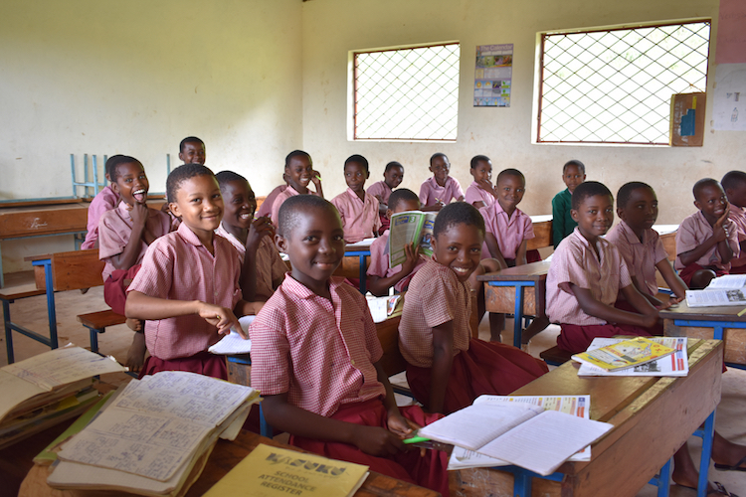

Making a difference

Bad news but getting better

Other reports

MAKING A DIFFERENCE
We (Angela and Gordon) have once again had the
privilege to visit the school and community during
early October.
Our most important ‘bring home message’ is that the school is doing really well.

Some further improvements to the infrastructure have been made and these will be reported later in this newsletter.
However, the most important message is that the amount and quality of teaching is having a very real and tangible positive impact. The pupils are motivated and eager to learn and the teaching staff are equally motivated and keen to teach.

We met the new Head Teacher and all of the teachers at least briefly. We spent much more time with the four “nursery” teachers who are Madam Jane (the lower school lead) and her team of Loice, Margaret and Agnes.

What is clear is that the 320 pupils are learning well and doing well. As we looked round all the classes were fully engaged, teachers were working enthusiastically engaging with their pupils.

There is a real buzz about the school and at lunch break it was heart-warming to be greeted by so many joyful children happily playing or coming to meet us to say JAMBO.

We were at school at 6:45 am one morning watching children arrive – mostly having walked some distance. Many of them brought sticks for the fire to help with the cooking. Again, they were happy and enthusiastic about starting a new day.

These are the positive outcomes that your support is delivering and everyone at school asks us to pass on their appreciation.

Your support IS making a difference to individual children, to their families and the community.

BAD NEWS GETTING BETTER
Elvis Makonde, brother of Revd. Charles Makonde, is our principal contact with the school in his role as Chairman of the School Feeding and Development Committee.
During August Elvis had an infection in the toes of his left foot resulting in some being amputated. The infection continued to spread and finally Doctors decided that amputation of the leg, just below the knee, was essential.
This operation did fully remove the infection and after some time in hospital the wound healed and Elvis is now back home. We visited him at home and he is doing well. Over the next few weeks he hopes to have a prosthetic leg fitted and then commence rehabilitation.
His active involvement has been much missed and we all hope and pray that he will be ‘back in action’ soon.
OTHER REPORTS
In the June newsletter we said that we would include the following:
Next time
- Update on the nursery play area completion
- What plans we have to improve hand washing and sanitation facilities as soon as funds permit
- Hopefully some exciting news about a play area project
- General funding plans for 2019
Nursery play area.
As the pictures below show the area is fully completed and well used. Whilst we were visiting the area was well supervised by teachers and the younger children were having a great time.
Having some fun at school is a good thing.

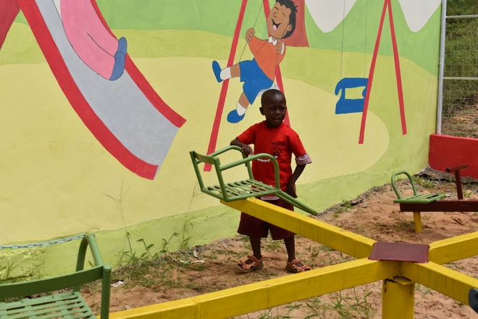 | 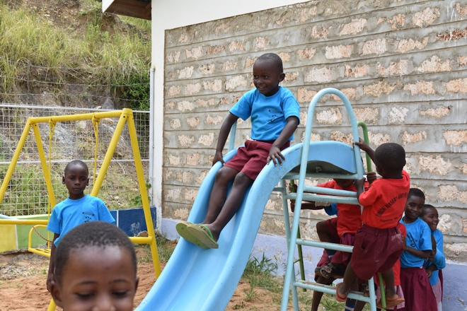
Hand washing and sanitation.  The single tap has been replaced with the tap station seen here. The waste water is fully drained away from the site. Out of picture the waste water from the kitchen area is also drained away and a ‘bridge’ has been built between the classroom walkway and the kitchen. This is all a big improvement and has fully removed the wet area.  A possible project to add a covered area with tables behind the new ‘bridge’ is being considered. | 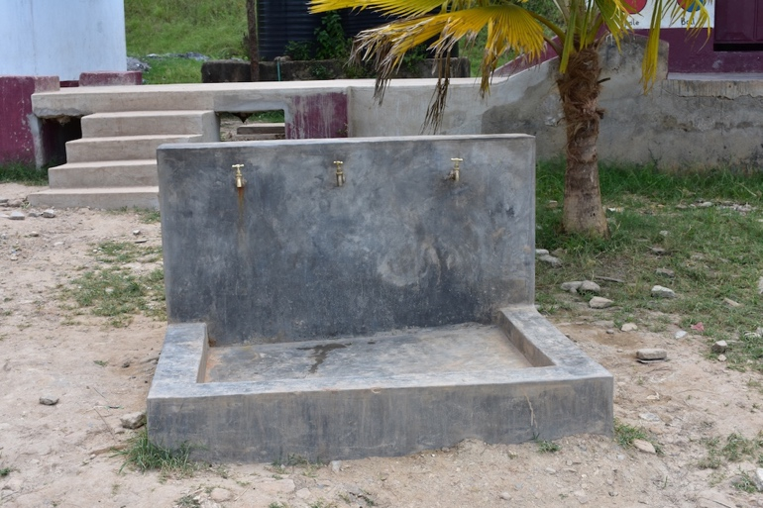
Playing field project
Thanks to some additional generous funding the main school land has been transformed into a flat playing field. For those who have not seen the previous area it was very rocky and undulating on many levels. (The whole area was an abandoned stone quarry)
Whilst the main area has been completed and a large flat area fit for play is now available, once the grass grows, there are still some parts to be completed. Due to the rocky nature of the ground the work was considerably more difficult to complete than expected and available funds have been used up. The local community are exploring ways to have all the work completed.
This is another significant development for the community.
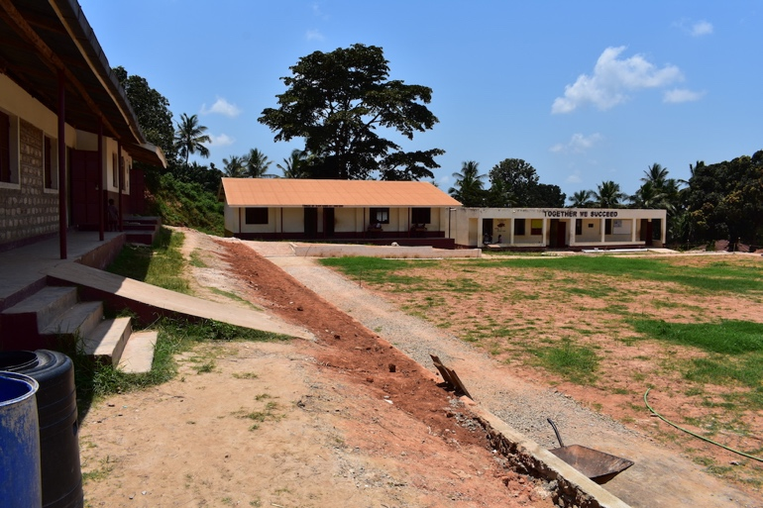 | 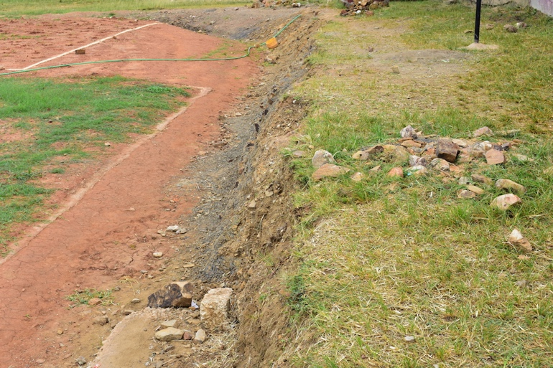
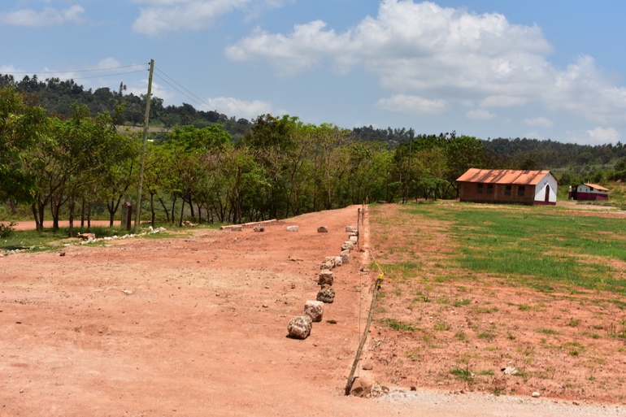 | 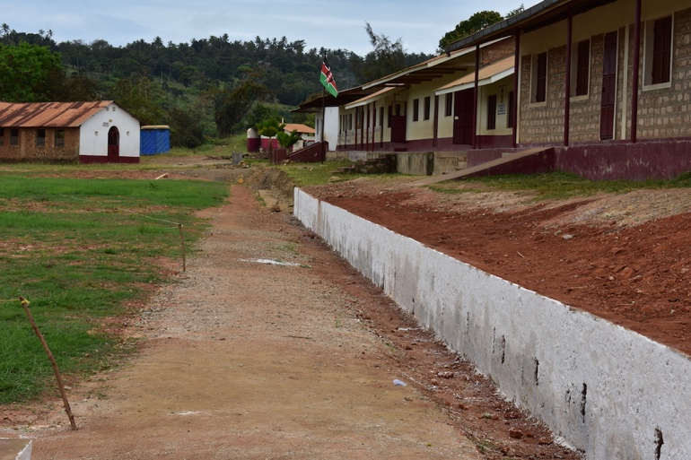
Funding plans for 2019.
The school has presented a budget for 2019 covering nursery school costs, provision to support part of the feeding programme and additional teaching staff. Trustees are committed to supporting the school during 2019 and have approved this budget.
Other funding possibilities are still under discussion and decisions will be taken as and when appropriate.
Some further donations have already been received towards mosquito nets and we will arrange with Madam Jane, head of the pre-primary section, to ensure the new class who enrol in January 2019 are supplied with nets.
A few more photographs
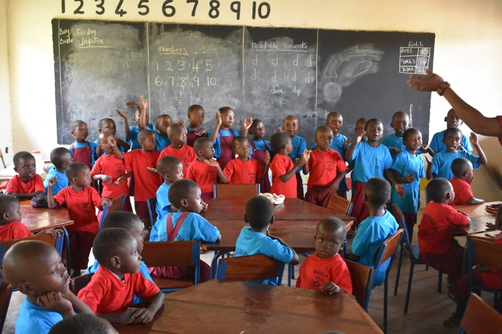 | 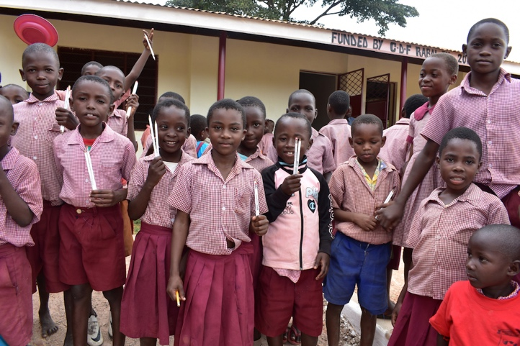
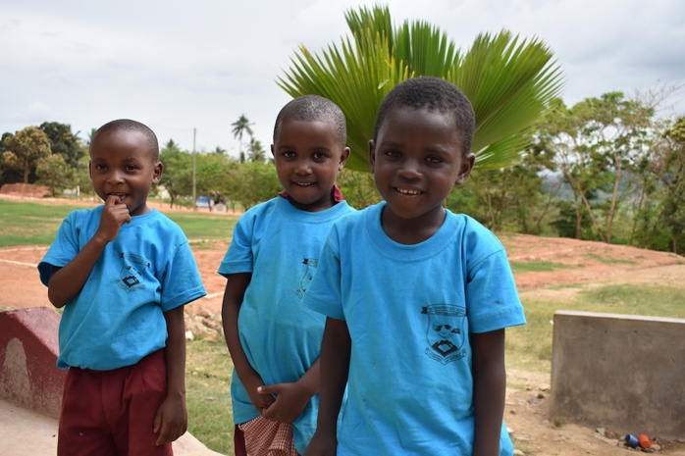 | 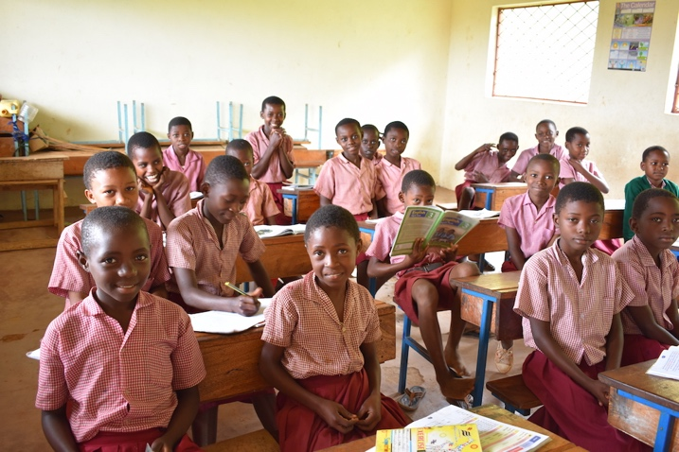

Just a thought………..

You may like to consider holding a mosquito drive** to help drive out mosquitoes.
It might be something to help raise funds to support the supply of mosquito nets to school.

** Like a beetle drive but different !!
RIVIERA TRAVEL
Please consider the ‘funds for nothing’ opportunity with Riviera Travel if you have the chance.
If you or anyone you know requests a brochure or books a holiday with Riviera just say the following few words “Please link my booking with Under The Mango Tree”
At absolutely no cost to the holiday maker Riviera will send funds to the charity,
----- it seems so simple, and it is
www.rivieratravel.co.uk

Contact details:
Under The Mango Tree
c/o 73 Carlton Road
Northwich
Cheshire
CW9 5PW
Email = utmtcharity@gmail.com

*** Please take a look at our latest web site pages
www.underthemangotree.org.uk

and finally; please remember that 100% of donations go to the school projects. All administration and any other running costs are covered by trustees or other generous volunteers.

